FIN3080 Assignment 3

121090885 Zhu Yuanhao

In this assignment, we have two questions which is all about sorting and visualizing. So we can directly download the datasets, and do some operations like what have done in the last assignment, and draw the graph.

The first question asks us to sort and construct ten portfolio by the last month’s return. So we directly download the datasets of the individual stocks’ monthly return, and mutate a new column, which exactly is the last month’s return. So that now according to different time, we use the function to mutate a column which shows the number, or the quartile of the return in the same month. Then we can group the data by the time, and use the mean of the return to be our portfolio’s return (because of equal weight). Thus, we have ten portfolios with their monthly returns from 2012-01 to 2022-12, and we can draw the graphs. Here below are the results.

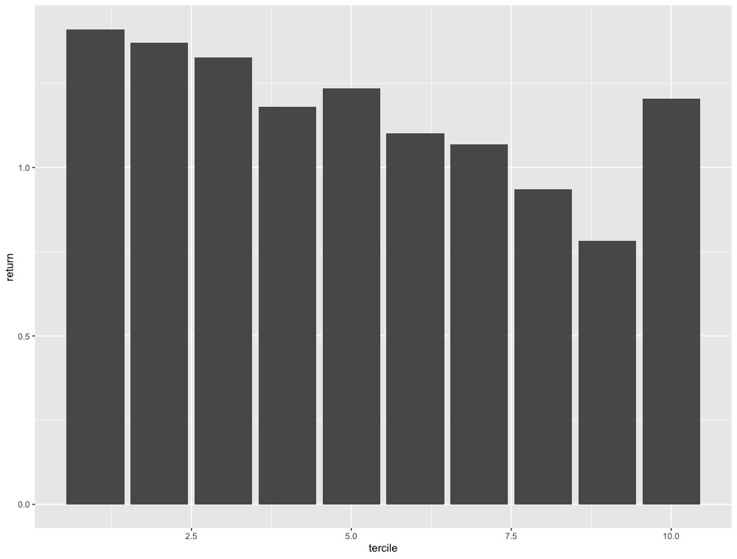

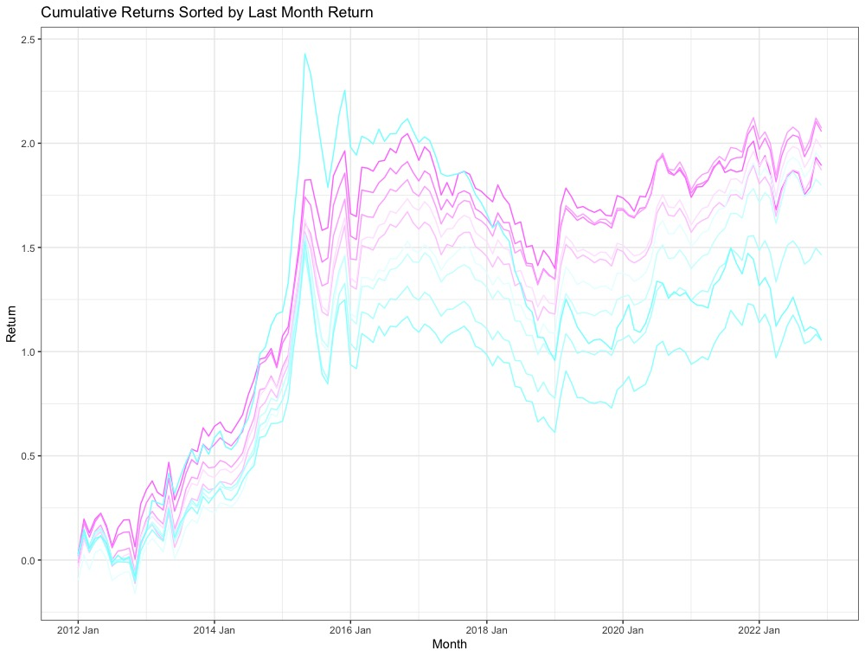

Where the bar graph shows the average return of the ten groups, and the time series graph shows the return from 2012-01 to 2022-12, and the color changes from purple to blue with respect from small last month’s return to high last month’s return.

Thus from the bar graph we can see that, the smaller the last month’s return is, the larger average return the portfolio will have. This looks true because when last month’s return is low, its price in the current month will be relatively low, and the return for the current month will intend to be high. However there is a high bar at group ten, I think this is because group ten has some extremely high return at some time period, which push the average to a really high place (can also be seen in the time series graph).

From the time series graph we can see that the purple lines, i.e. with smaller last month’s return, the higher is the return for the current month, this leads to the same conclusion of the result showed in the bar graph, and we can see that about 2015 one blue line, that is the group ten, reaches to a really high place, which means that point push the average to a high place.

The second question asks almost the same thing, just change the principle of sorting to last quarter’s ROE. Thus firstly we download the datasets of the ROEs. Here, I downloaded both ROE-A and ROE-ttm, to both have a look the results. Then what need to be done is to construct the quarterly return data. Instead of using the closing price, I use the multipiler of every month’s return + 1 in the same quarter and then -1 to let it be the quarterly return. Then I added the roe’s corresponding quarter, to let it has the same quarter with the data of the returns, and then combine the two datasets. Then use the similar method done in the previous question, we can construct ten groups of portfolios to see its cumulative returns. And here is the result below

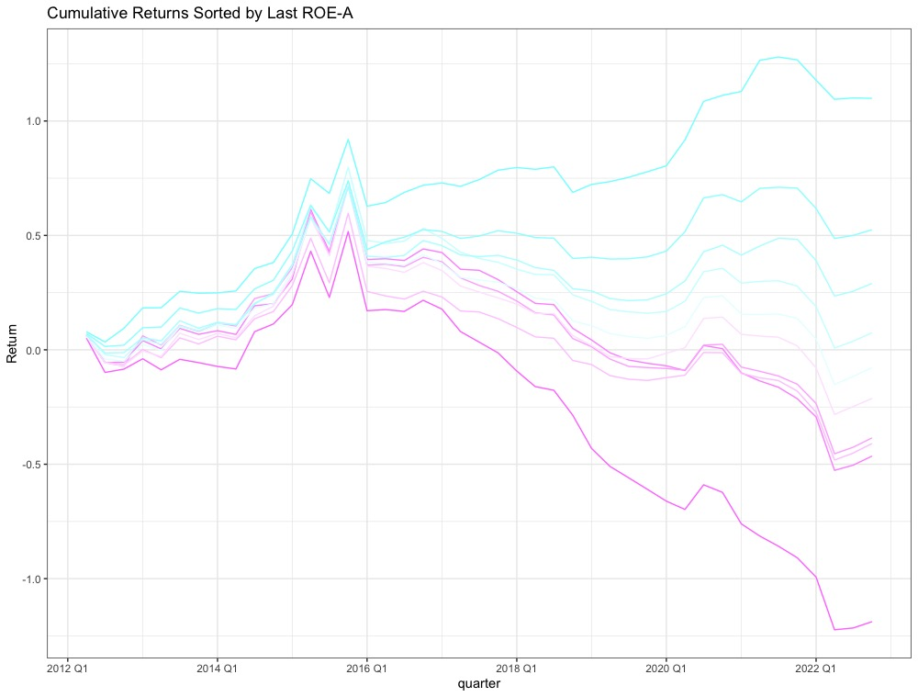

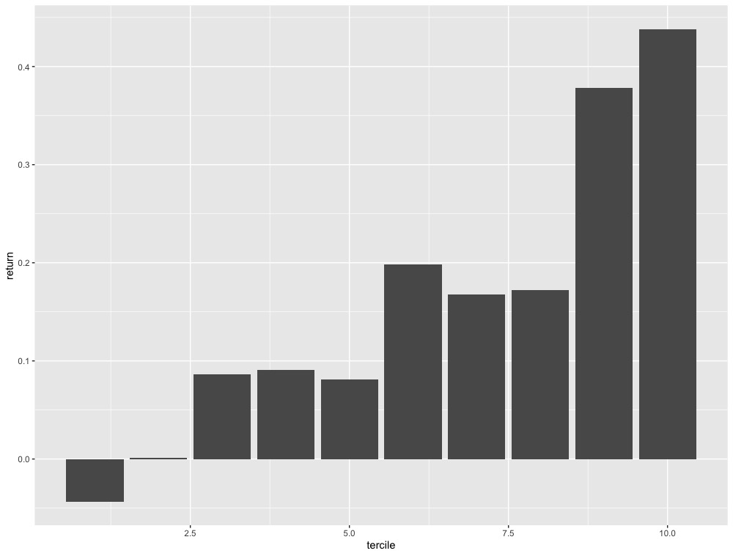

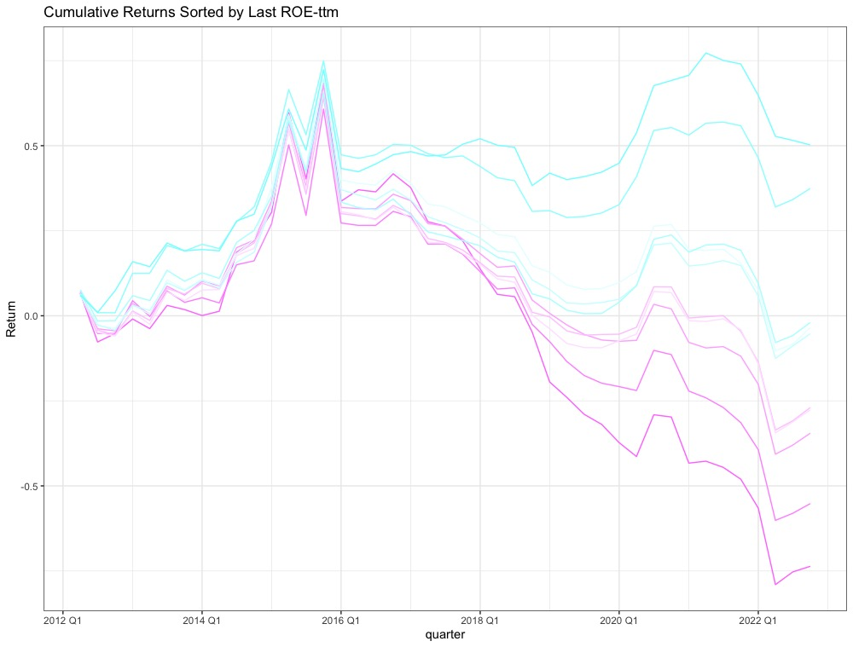

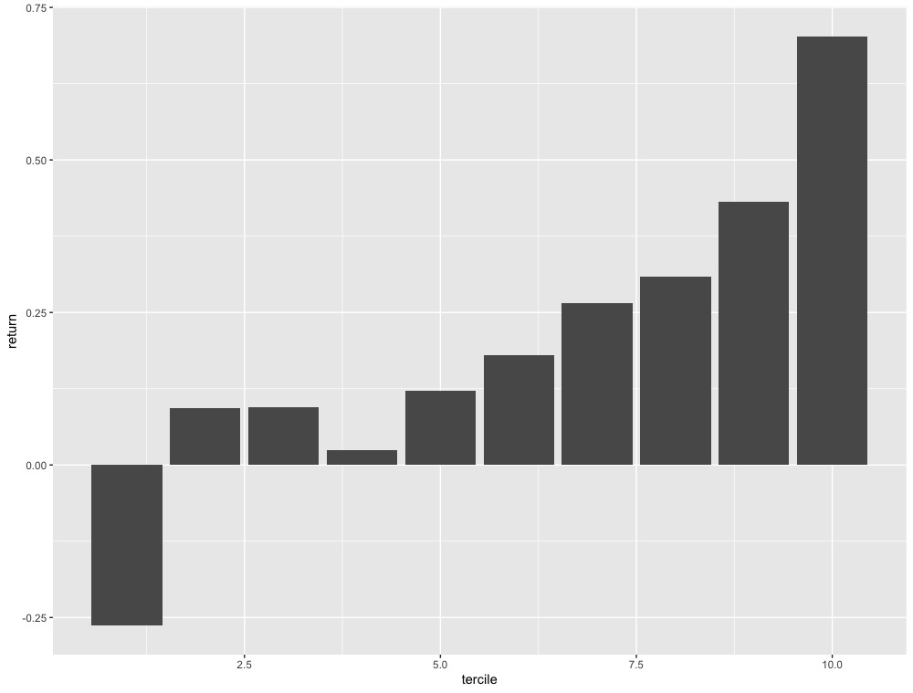

Also, the color changes from purple to blue with respect from less last quarter’s ROE to high last quarter’s ROE. It is much easy to see that the purple line, i.e, the less the last quarter’s ROE is, the less the return of the current quarter will be. And the results are the same whatever using ROE-A or ROE-ttm. This means that low ROE will lead to low return in the next period. This can be explained as, with low ROE, i.e return on equity is low, the amount of the return invested in the stock will be low. The two conclusions show that the return showed in the stock market has the different effect or meaning of ROE, which represents the company’s true profit and the shareholders’ equity.